**Fake News detection**

**Nguyen Duc Khuong Duy (Team leader); Hoang Anh Duc; Dao Nhat Tan; Bach Trung Kien**

**Advisor: Le Dinh Huynh**

**Abstract:** The proliferation of fake news in today's digital age poses a significant threat to the integrity of information dissemination. With the rise of social media and online news platforms, false and misleading information spreads rapidly, creating confusion, undermining trust in reliable sources, and even influencing public opinion.

**Keywords:** Fake News detection, NLP, Machine Learning, Logistic Regression

**1. Introduction**

In the contemporary digital landscape, the rampant spread of fake news presents a critical obstacle to the integrity of information dissemination. The exponential growth of false and deceptive content across social media and online news platforms not only engenders confusion but also erodes trust in credible sources, exerting influence on public opinion. As the volume of internet-generated content continues to escalate, conventional fact-checking methods and manual verification struggle to cope.

This project is motivated by the imperative to safeguard the credibility of information sources and mitigate the accessibility of fake news. By addressing the detrimental effects of misinformation on individuals and fortifying the trustworthiness of the information ecosystem, this initiative endeavors to uphold the integrity of information dissemination. Additionally, it aims to provide support to journalists, fact-checkers, and news organizations in enhancing the accuracy of their reporting and combatting the swift dissemination of false information across diverse online platforms.

# 2. Related Works

Amidst the surge of technological advancements, significant research and innovations have emerged in the realm of fake news detection. These endeavors aim to enhance the precision and efficiency of identifying and preventing the spread of misinformation. Such efforts have played a crucial role in advancing the state of the art in fake news detection techniques, paving the path for the creation of more robust and reliable systems to combat the detrimental impacts of misinformation dissemination.

**2.1. Online News Credibility Evaluation with Bayes Model** [**[1]**](https://ieeexplore.ieee.org/document/9384594)**:**

The paper presents a comprehensive approach to evaluate the credibility of online news using Bayesian reasoning. The authors first establish an index framework comprising various indicators that influence the credibility of news articles, such as headline relevance, absolute content, citation volume, media credibility, etc. They then construct a mathematical model based on Bayesian reasoning theory to calculate the probability of news credibility considering different attributes. In the experiment, the authors collected sample data and processed it using the k-means clustering method to classify and quantify the attributes. They applied the Bayesian formula to calculate the prior and posterior probabilities of news credibility for each attribute. The obtained results were compared with evaluations made by domain experts. The main findings of the experiment reveal that the model generated data with considerable variation, indicating some degree of instability. The comparison between the model's calculated values and the actual evaluations by experts showed discrepancies, although the model provided a systematic approach to evaluate news credibility. One limitation of the study is the potential subjectivity in defining and quantifying the indicators used in the model. Additionally, the model's performance could be affected by the quality and representativeness of the training data. Moreover, the Bayesian approach may have inherent assumptions and constraints that could impact the accuracy of the credibility evaluations.

**2.2. Fake News Detection using Deep Learning** [**[2]**](https://ieeexplore.ieee.org/document/9108841)**:**

The paper addresses the pressing issue of fake news proliferation in the digital era. The authors propose utilizing natural language processing (NLP) techniques and deep learning models to detect fake news based on news titles or content. They collect and clean a dataset comprising news titles, content, and labels (real or fake). The data is explored to understand its characteristics and imbalance, followed by preprocessing involving text processing methods like regular expression, tokenization, lemmatization, and stop words removal. Four similar neural network models are trained using TensorFlow and Keras, with varying input data (N-gram vectors or sequence vectors) derived from news titles or content. The obtained results demonstrate that models trained with news content achieve better performance, with higher accuracy and recall rates, albeit at the cost of increased computational time. Conversely, models trained with news titles exhibit faster computation but lower performance metrics. This trade-off suggests that the choice of input data (title or content) depends on the application context, such as real-time social media platforms or feed-based platforms like Facebook and Twitter. The authors also highlight future research directions, including parameter tuning, employing recurrent neural networks (RNN) with LSTM algorithms, and exploring multimedia data (images, videos) for improved detection. The paper's strengths lie in its systematic approach to addressing the fake news detection problem, leveraging NLP techniques and deep learning models. The experimentation is well-structured, with clear data collection, preprocessing, model training, and evaluation steps. Additionally, the authors provide comprehensive discussions on the implications of their results and offer valuable insights into future research directions.

**2.3. News Credibility Evaluation on Microblog with a Hierarchical Propagation Model** [**[3]**](https://ieeexplore.ieee.org/document/7023340)**:**

The research conducted by Sheng How Kong, Li Mei Tan, Keng Hoon Gan, and Nur Hana Samsudin focuses on fake news detection using deep learning techniques. The main approaches employed in the study include natural language processing (NLP) techniques for text analytics and training deep learning models to detect fake news based on news titles or content. The authors propose four neural network models trained with different text vectors: N-gram vectors and sequence vectors, applied to both news titles and content. The data collection involved combining English news datasets from various sources, focusing on news titles, content, and labels (0 for real news and 1 for fake news). Data cleaning was performed to remove empty, repetitive, and problematic rows. Data exploration was conducted to understand the distribution of real and fake news, word counts, and identify common terms in each category. Data preparation involved text preprocessing techniques such as regular expression, tokenization, lemmatization, and stop words removal, followed by vectorization into N-gram or sequence vectors using TF-IDF or one-hot encoding. Four similar neural network models were trained using Keras and TensorFlow, with layers incorporating rectified linear unit (RELU) activation functions and dropout layers to prevent overfitting. The evaluation of the models focused on accuracy, recall, and computational time. Results indicated that models trained with news content achieved better performance compared to those trained with news titles, with higher accuracy and recall rates. However, models trained with news content required longer computational time due to the larger vocabulary size. Models trained with news titles demonstrated faster computation and still achieved high recall rates, making them suitable for real-time applications such as social media platforms. The limitations of the study include the reliance on English news datasets, which may not fully represent the characteristics of fake news in other languages or regions. Additionally, while the proposed models showed promising results, further optimization and tuning of parameters could potentially improve performance. Moreover, the study did not address the deployment of the models in real-world social media platforms, leaving room for future research in this area.

**2.4. Fake News Detection Using Naive Bayes Classifier** [**[4]**](https://ieeexplore.ieee.org/document/8100379/)**:**

The paper "Fake News Detection Using Naive Bayes Classifier" presents a method for detecting fake news using a naive Bayes classifier. The authors introduce the problem of fake news proliferation, particularly on social media platforms, and propose using machine learning and artificial intelligence techniques to address it. Their main approach involves implementing a naive Bayes classifier, a probabilistic model based on Bayes' theorem, to classify news articles as either true or fake based on the presence of specific words. They leverage the similarity between spam messages and fake news articles and apply techniques commonly used in spam filtering, such as bag-of-words features. For their experiment, the authors used a dataset collected by BuzzFeed News, consisting of Facebook posts labeled with categories like "mostly true," "mostly false," etc. They divided the dataset into training, validation, and test sets and implemented the classifier using the training data. They then evaluated the classifier's performance on the test set. The obtained results showed a classification accuracy of approximately 75% for both true and fake news articles. However, the precision for fake news detection was higher than the recall, indicating that while the classifier was good at identifying fake news when it did, it missed many instances due to the skewness of the dataset. One limitation of their approach is the relatively small dataset used for training, which consisted of around 2000 articles. The authors suggest that obtaining more data and using longer news articles could improve the classifier's performance. Additionally, they propose several other enhancements such as removing stop words, applying stemming, and treating rare words separately.

**2.6. Overall:**

In the landscape of fake news detection, various methodologies have been explored, each with its strengths and limitations. From Bayesian reasoning models to deep learning techniques, researchers are striving to develop more robust systems to combat misinformation proliferation. While approaches like Bayesian models offer systematic frameworks, they may suffer from subjectivity in defining indicators. On the other hand, deep learning methods show promise in leveraging NLP for improved detection, albeit with computational challenges and dataset biases. Moving forward, addressing these limitations and focusing on real-world deployment will be crucial for advancing the effectiveness of fake news detection systems.

# 3. Data Preparation

**3.1. Overview:**

In this section, we outline the methodology employed for the data collection process. The dataset used for this report is a consolidated and cleaned-up version of the open-source Fake News dataset. The collection process involved scraping articles from various news websites between the end of 2017 and the beginning of 2018. The dataset comprises 647 distinct sources, encompassing a wide range of news topics.

**3.2. Data Exploration:**

After the 2 datasets have been collected, combined, and cleaned, the final news dataset will then have 3 attributes, which are title, text,label representing news title, news text and news label respectively as shown in Table 1 :

**Table 1:** 3 sample rows of collected, combined and cleaned news dataset

|  | **Title** | **Text** | **Label** |
| --- | --- | --- | --- |
| 0 | As U.S. budget fight looms, Republicans flip t... | WASHINGTON (Reuters) - The head of a conservat... | 1 |
| 1 | U.S. military to accept transgender recruits o... | WASHINGTON (Reuters) - Transgender people will.. | 1 |
| 2 | Senior U.S. Republican senator: 'Let Mr. Muell... | WASHINGTON (Reuters) - The special counsel inv... | 1 |
| 3 | FBI Russia probe helped by Australian diplomat... | WASHINGTON (Reuters) - Trump campaign adviser ... | 1 |
| 4 | Trump wants the Postal Service to charge 'much more... | SEATTLE/WASHINGTON (Reuters) - President Donal.. | 1 |

In the data exploration stage, the dataset label ratio is first to be examined to know whether the dataset is imbalanced which could possibly affect the outcome of the model training in the later stage. By getting the total count for each label and visualizing using a bar chart in Figure 1, the dataset can be considered as a balanced dataset such that the ratio of real news to fake news is nearly 50:50.



**Figure 1:** Dataset Labels Ratio



**Figure 2:** Word count for real news in ratio form

Then, word counts in ratio format are plotted for each news label to determine if there are any significant words that contribute to the real or fake news used. Figure 2 shows the word cloud and the top 20 words for real news respectively while Figure 3 shows the word cloud and top 20 words for fake news respectively.



**Figure 3:** Word count for fake news in ratio form

**3.3.Method:**

As could be observed from both the word cloud and top occurring words, many words like “said”, “Trump”, “one” and more are appearing frequently in both real and fake news. This indicates that all these words or terms are common in many news articles regardless of the labels and can possibly be ignored or given a smaller weight when training the model.

# 4. Methods

**4.1 Overview:**

We separate this problem into two stages:

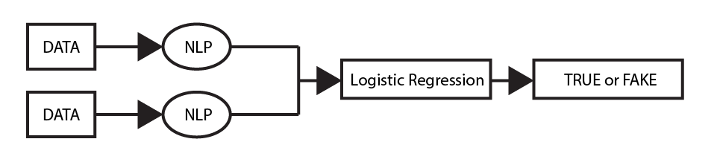

**Figure 4:** Example of the process.

**4.1.1. Stage 1: Data processing**

Because all of the data we get is through newspapers so stop words like ‘the’, ‘and’, and ‘I’, although common, don’t usually provide meaningful information about a document’s specific topic. By eliminating these words from a corpus, we can more easily identify unique and relevant terms. After that we convert it back to a str ease of use

**4.1.2. Stage 2: Data processing**

The Bag-of-Words (BoW) model is pivotal in detecting fake news, forming the basis of many NLP-based approaches. It treats text as a mere collection of words, disregarding grammar and sequence. By quantifying word frequencies, it constructs a vector representation, aiding in classifying news articles as genuine or fabricated. However, its limitation lies in overlooking context and semantics, necessitating more sophisticated models for comprehensive fake news detection. We put our data through CountVec from sklearn library to turn all the words into a vector. We only take the unigrams and bigrams. After that we can put it into our machine learning model.



For every data point we get 2504111 features with the BOW approach.

**4.2.1 Train model:**

Logistic Regression is an optimization problem that minimizes a cost function. Regularization adds a penalty term to this cost function, so essentially it changes the objective function and the problem becomes different from the one without a penalty term. Regularization generally refers to the concept that there should be a complexity penalty for more extreme parameters. A low value tells the model to give more weight to this complexity penalty at the expense of fitting to the training data. So we create a simple model with sklearn library with the value of C=2.5 ,datetime to calculate the runtime of the model and pickle to save the model.

# 5. Implementation

**5.1. Creating sign references:**

During this procedure, our personal computer doesn't have enough computational power so we deploy the model on Cloud, which is Google Colab, for extracting data. We used the True and Fake dataset for references, extracted by using the CountVec Model. After extracting, we store our references dataframe to two files as Train and Test .Then we train the Logistic Regression model and calculate its F1 score with sklearn and save the model to our local computer with pickle library.

**5.2. Real-time deployment:**

We will handle everything on personal computers in this section. We use easygui to create a popup to communicate with the users. The user needs to fill the link of the newspaper to our GUI. If it's in our dataset we will automatically return a label.

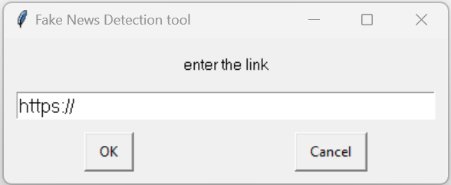

**Figure 5:** Example of the process.

If not we make another popup and the user need to fill in the content and text of the newspaper and then we put it through our model to hand out a answer



**Figure 6:** Example of the process.

**6. Results and Discussion**

**6.1 Results**

The experimental results were achieved using a evaluation metric F1-Score with an impressive performance of 0.998:

$F1=\frac{2 * Precision * Recall}{ Precision + Recall}$

This high F1 score suggests that the model achieved a balanced trade-off between precision and recall, indicating accurate classification across different classes.

The obtained confusion matrix further corroborates the model's effectiveness in correctly predicting class labels. However, it is essential to remain vigilant about overfitting and high number of features

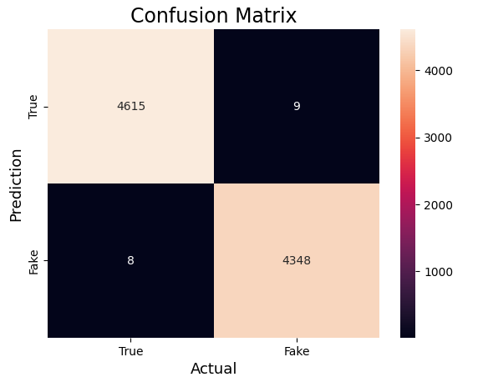

**Figure 7:** Example of the process.

**6.2 Discussion**

In the future, we will strive to make the implementation of this project more user-friendly, allowing users to easily access it through a mobile app or a web extension for their convenience. Additionally, we will make efforts to overcome past challenges such as limited data, financial constraints, and rudimentary equipment. Furthermore, we will aim to deploy the model with better equipment and resources, along with a larger dataset to work with, in order to achieve more efficient results.

# 7. References

1. Y. Si, J. Wang, X. Dong, G. Wu, Z. Zhong, G. He, and F. Chen, “Online News Credibility Evaluation with Bayes Model”. *International Conference on Big Data and Information Analytics*, pp. 340–346, 2020.
2. S. H. Kong, L. M. Tan, K. H. Gan, N. H. Samsudin, “Fake News Detection using Deep Learning”. *Symposium on Computer Applications & Industrial Electronics*, pp. 102-107, 2020.
3. Z. Jin, J. Cao, Y. Jiang, Y. Zhang, “News Credibility Evaluation on Microblog with a Hierarchical Propagation Model”. *IEEE International Conference on Data Mining*, pp. 230-239, 2014.
4. M. Granik, V. Mesyura, “Fake News Detection Using Naive Bayes Classifier”, *IEEE First Ukraine Conference on Electrical and Computer Engineering*, pp. 900-903, 2017.

# Appendix A. Project Plan management

| **#** | **WBS Item** | **Complexity** | **Est. Effort** | **Person** |
| --- | --- | --- | --- | --- |
| ***1*** | ***Initiation*** |  |  |  |
| 1.1 | Confirm project goals and objectives | Medium | 1 | *N.Đ.K.Duy* |
| 1.2 | Create a Project Charter, outlining the project's scope, constraints, and assumptions. | Medium | 2 | *All* |
| 1.3 | Determine the initial feasibility of the project. | Medium | 2 | *All* |
| 1.4 | Confirm roles and tasks within the group | Simple | 1 | *N.Đ.K.Duy* |
| 1.5 | Researching | Medium | 3 | *All* |
| 1.6 | Writing reports | Simple | 1 | *N.Đ.K.Duy* |
| ***2*** | ***Data Collection and Preparation*** |  |  |  |
| 2.1 | Collect data | Medium | 3 | *Đ.N.Tân,*  *B.T.Kiên* |
| 2.2 | Data annotation | Simple | 2 | *Đ.N.Tân,*  *B.T.Kiên* |
| 2.3 | Clean and preprocess the data | Medium | 4 | *H.A.Đức*  *N.Đ.K.Duy* |
| ***3*** | ***Feature Extraction*** |  |  |  |
| 3.1 | Choose suitable feature extraction techniques | Medium | 4 | *All* |
| 3.2 | Extract key characteristic of the news | Simple | 2 | *All* |
| 3.3 | Design and train the model using the prepared dataset | Complex | 5 | *H.A.Đức* |
| 3.4 | Implement appropriate loss functions and optimization algorithms | Medium | 3 | *All* |
| 3.5 | Fake News Detection | Medium | 3 | *All* |
| ***4*** | ***Model deployment*** |  |  |  |
| 4.1 | Model Integration and Application | Complex | 4 | *Đ.N.Tân,*  *N.Đ.K.Duy* |
| 4.2 | Test and validate model performance | Complex | 5 | *All* |
| 4.3 | Model Monitoring and Management | Medium | 4 | *All* |
| ***5*** | ***Evaluation and refinement*** |  |  |  |
| 5.1 | Evaluating Model Performance | Medium | 3 | *Đ.N.Tân,*  *H.A.Đức* |
| 5.2 | Analyze results and compare with original goals | Medium | 2 | *B.T.Kiên* |
| 5.3 | Refine and Improve the Model | Medium | 4 | *All* |
| 6 | ***Testing*** |  |  |  |
| 6.1 | Test the Model in Real Time | Medium | 3 | *All* |
| 6.2 | Handle errors and problems that arise | Medium | 3 | *Đ.N.Tân* |
| 6.3 | Evaluate Stability and Performance | Medium | 2 | *H.A.Đức* |
| 6.4 | Write the final project report | Simple | 1 | *N.Đ.K.Duy* |

# Appendix B. Source code & Data

| **Item** | **Link** | **Description** |
| --- | --- | --- |
| Data | https://drive.google.com/drive/folders/1YpTZ7vkMkyNSMMo7W5s7d65a8NS4Ykuu?usp=drive_link | An online community platform for data scientists and machine learning enthusiasts contains the Fire Detection in Images dataset. |
| Document | https://docs.google.com/spreadsheets/d/1a62SPqKjHXQwc_Yg5mIfJtg69irWI7egR7c-GmcEubw/edit?usp=sharing | Our managing document excel sheet. |
| Source Code | https://drive.google.com/drive/u/0/folders/10erNPWdBrqw-7fwkHUgty3B6f7e0uPlV | Google drive that contains the source code of the project. |